14. Demonstrate Infrastructure as a Service (IaaS) by creating a Virtual Machine using a Public Cloud Service Provider (Azure), configured with required memory and CPU.

Aim :

To demonstrate Infrastructure as a Service (IaaS) by creating and configuring a Virtual Machine (VM) in Microsoft Azure with the required CPU, memory, and storage, and to verify successful deployment and access.

Procedure :

- Log in to the Microsoft Azure portal using a valid Azure account.
- Access the Azure dashboard and select Resource Groups.
- Click Create and create a new resource group by providing the required details and region.
- Select Create a resource and choose Virtual Machine under Compute services.
- Assign the virtual machine to the previously created resource group.
- Enter the virtual machine name, select the operating system, and choose the same region.
- Select a minimum virtual machine size with 1 vCPU and 1 GB RAM.
- Configure authentication and choose Standard HDD with default storage settings.
- Use default networking settings and enable required inbound ports (SSH/RDP).
- Review the configuration and create the virtual machine, then verify the deployed resources in the resource group.

Output :
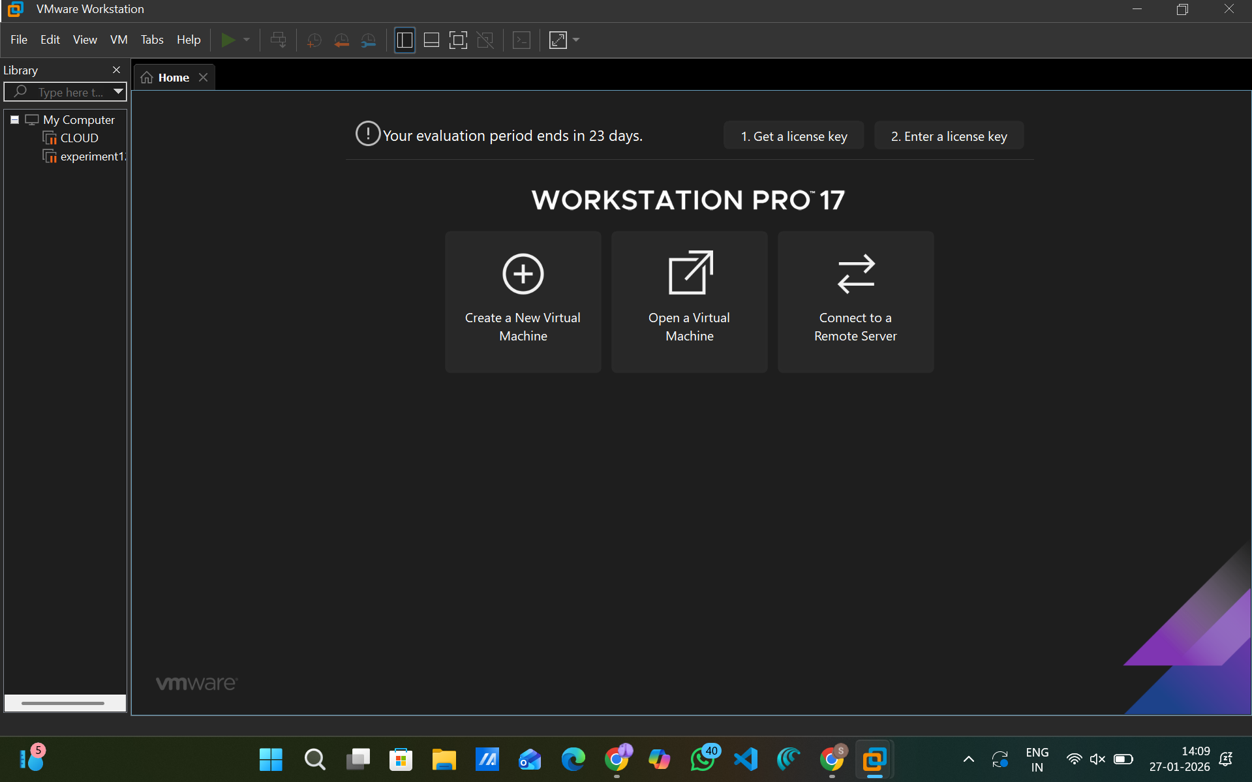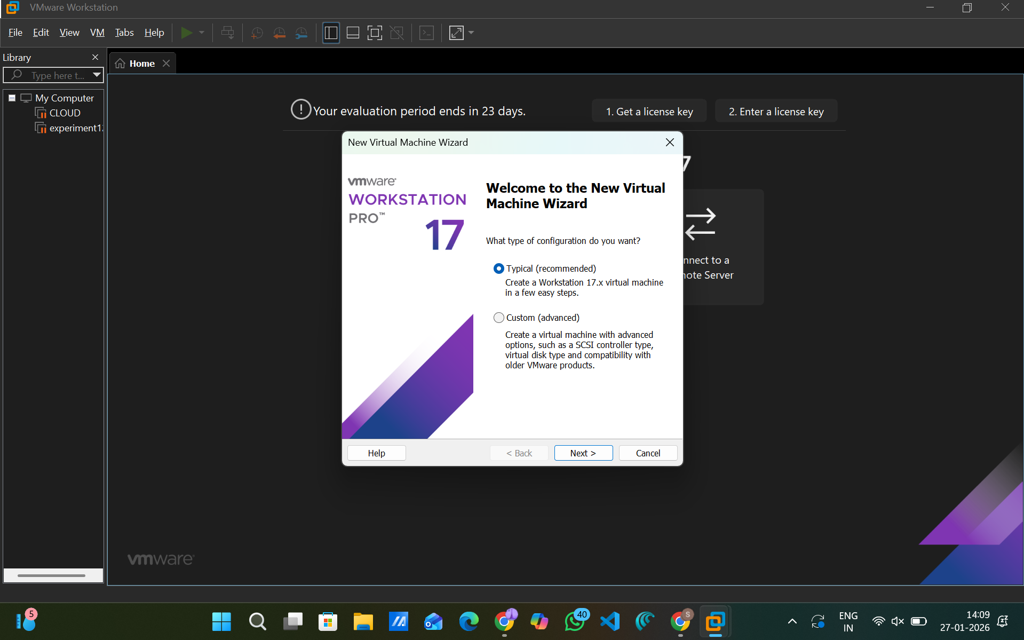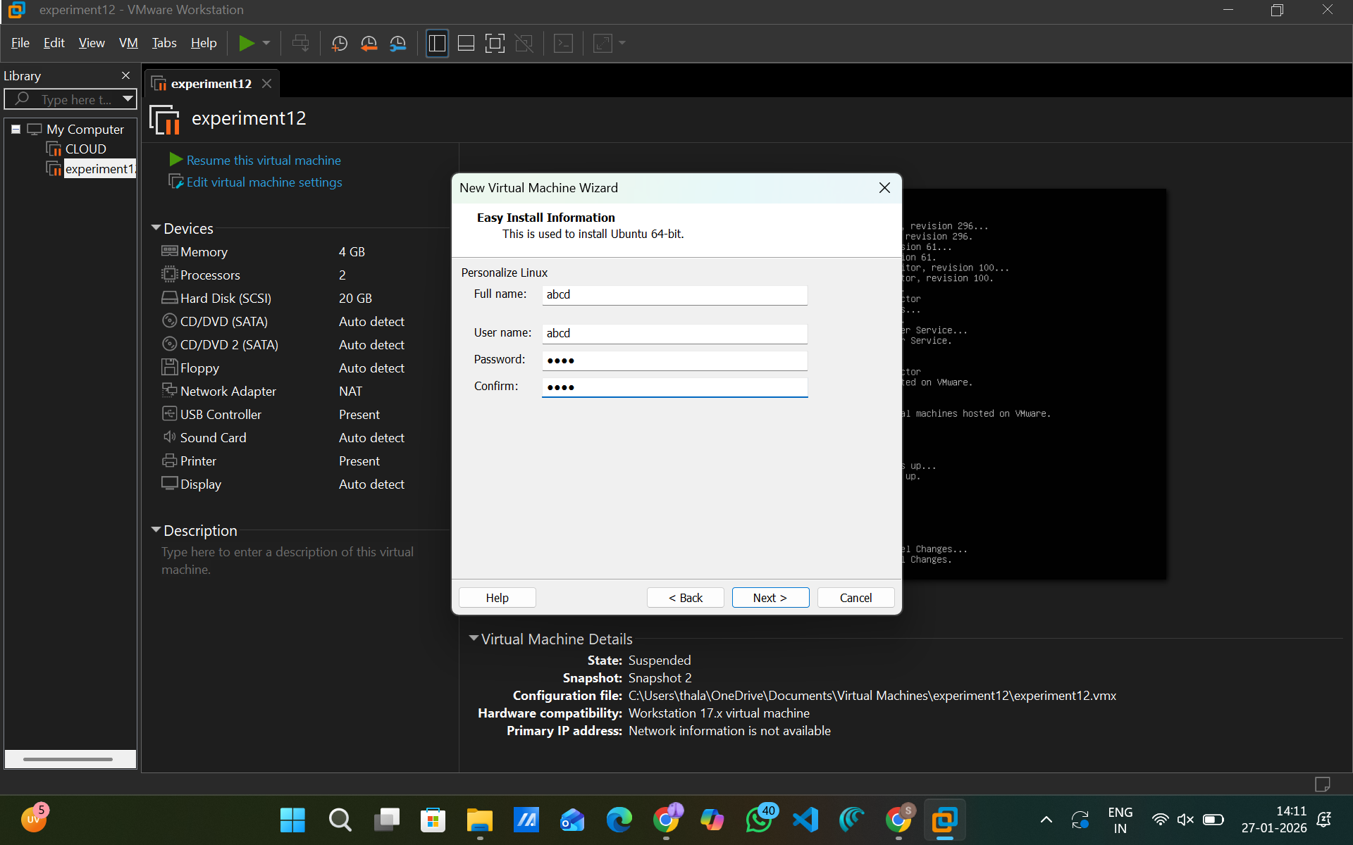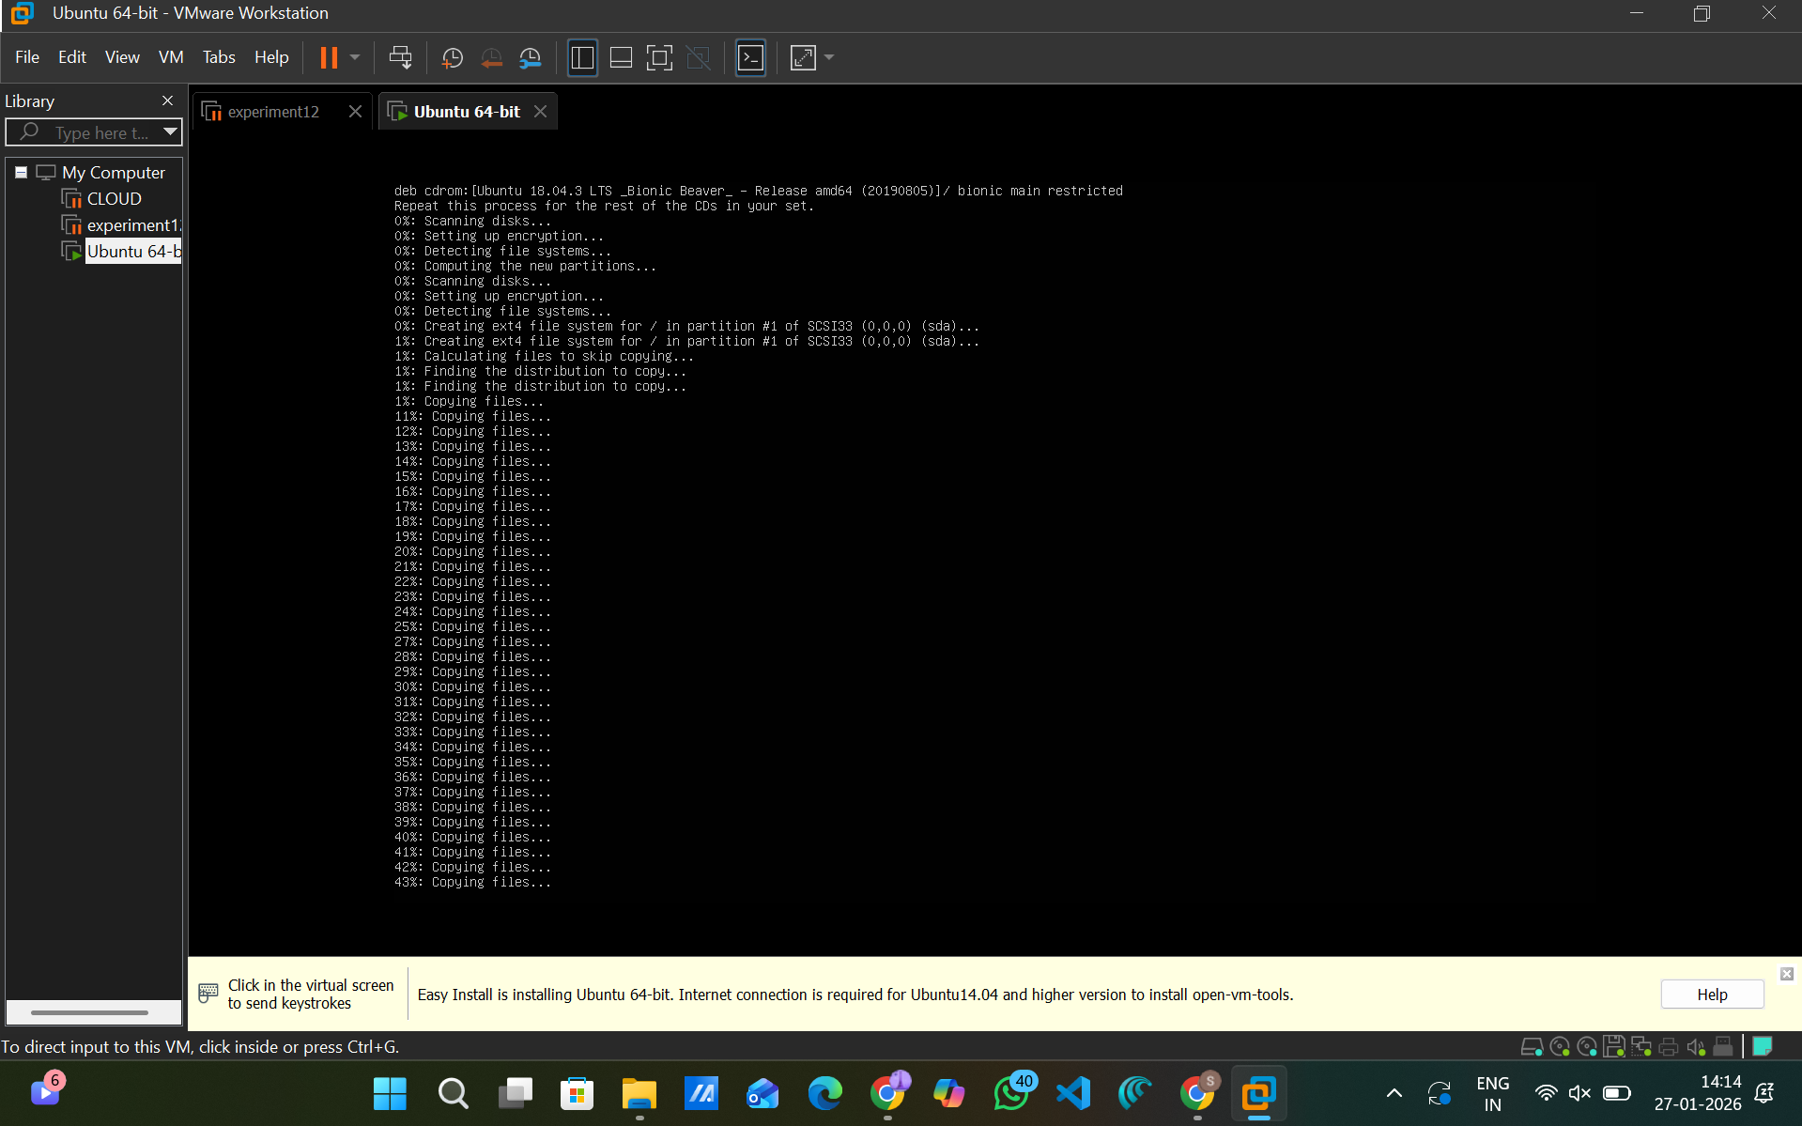

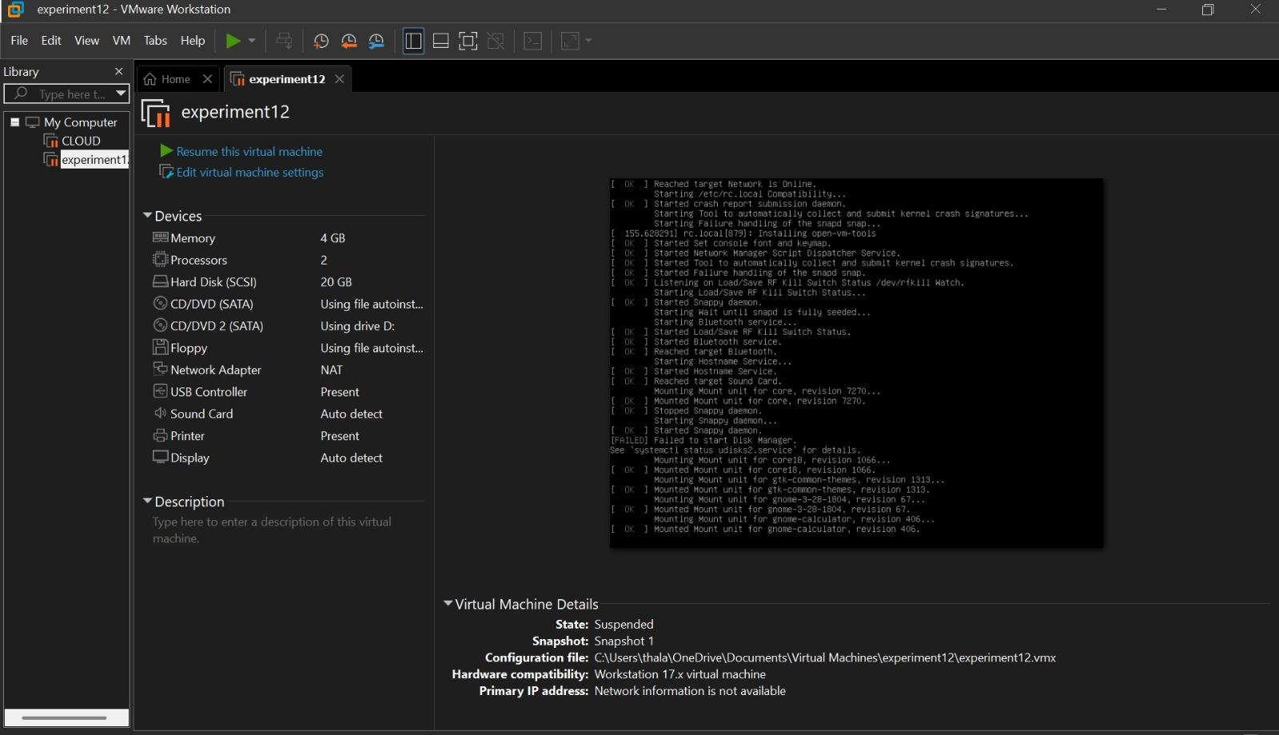

Result :

Virtualization was successfully demonstrated by installing a Type-2 Hypervisor (VMware Workstation) and creating and running a Virtual Machine with a guest operating system. The VM operated independently of the host system, confirming the effective implementation of virtualization.

